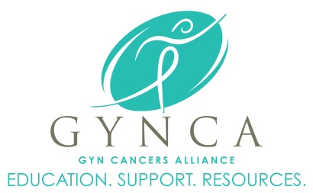

February 2016

MEMBERS ONLY

Enter Contact Information Here | 1127 Lombard Blvd. San Francisco, CA 59802 | phone 555.555.5555 | fax 555.555.5555

­

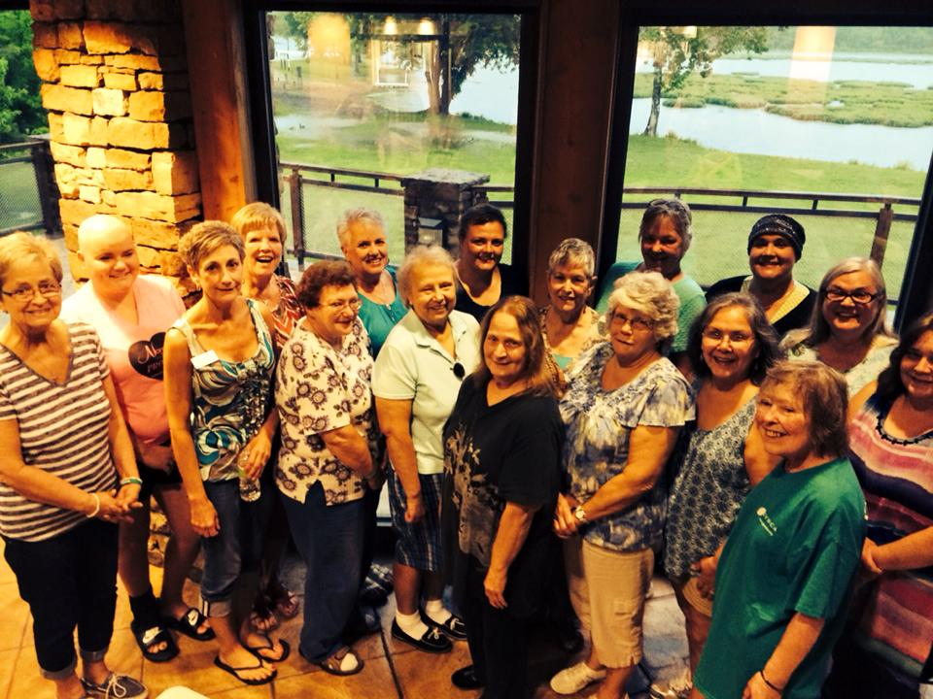

***Hope & Outreach … Touching One Life at a Time***

GYNCA is reminded daily through personal visits to the office or chemo rooms, notes, calls and emails that no two patients battling a gynecologic cancer are the same --- age, faith, diagnosis/prognosis, life experiences, socio-economic being and overall outlook on life. Each has her own unique way of coping with her cancer journey --- some with amazing family and caregiver support and some face the battle completely alone.

We serve ladies who *need* and *take advantage* of all GYNCA has to offer: fellowship with sister survivors at support groups; the receipt of the Member’s Only newsletter; needing gas cards or help with rent and utilities during treatment; attending GYNCA’s summer picnic in the park or annual Christmas party with family and friends; speaking to a sister survivor about your fears and frustrations; arranging for your husband or caregiver to talk to other caregivers about his/her personal fears and struggles; volunteering at a GYNCA event to raise awareness to the signs and symptoms of gynecologic cancers; or help raising money for direct-patient emergency assistance. We also have patients who just need to know they are not alone in this fight.

In thinking back to our friend and founder, Joy Lamberson-Klock, she often spoke about outreach and feeling hopeful … providing *hope* to the ladies we serve. Joy was a woman of strong faith and unwavering hope. Joy became a Woman of Courage through her every action and deed while making sure all her sisters battling ovarian and gynecologic cancers in southwest Missouri also felt Hope. While we defer to the medical professionals and researchers to treat and find a cure for gynecologic cancers, she was adamant that GYNCA, (formerly NEW HOPE - Now Every Woman Has Our Prayerful Embrace), reach out and serve as a beacon of hope for its patients and families.

On a recent regular visit to Dr. Jay Carlson’s infusion center to deliver gas cards and supplies to patients we were reminded of the highly-personal and individual toll cancer takes on each of you. Every chemo chair was occupied by a Woman of Courage … some appeared hopeful, but others appeared frightened, frail, exhausted. Upon returning to the GYNCA office I retrieved an email received in September of 2013, during the wee morning hours, from one of your own. No one portrays “hope” better than survivor and sister Woman of Courage, Sue George.

*“I AM A WOMAN OF COURAGE… Every day of every week of every month of every year, I deal with cancer. At times it can be very depressing and the tears come even when I try so hard to keep them away. But there are times that there is such joy; it is hard to imagine. Where does this joy come from? It comes from the many women I meet on this journey. Women who are fighting hard to stay alive. Women who are fighting this insidious disease. Women who take joy in the sun that shines and the rain that falls. Women who take strength from those who are helping them in this fight. Yes, that is you.”*

Continued on reverse….

A monthly newsletter for gynecologic cancer survivors, Members Only will feature articles, stories, inspiration, events, recipes and more written for survivors by survivors. Proudly published each month by GYNCA.

GYN Cancers Alliance (GYNCA) | 3023 South Fort Ave Suite D, Springfield, MO 65807 | phone 417.869.2220

Some reading this are newly-diagnosed and awaiting surgery or chemo; some of you are in the midst of chemo or radiation treatments; some of you are battling a 2nd, 3rd or 4th recurrence. We applaud and celebrate each and every one of you who continues to fight this fight. We love it when you “ring the bell” at the end of treatment cycles and there is no more evidence of disease; we are always hopeful that your fear of recurrence fades with the passing of time and that you can appreciate every day of your new normal. We also offer prayers, support and hope to our friends who will inevitably face recurrence due to the very nature of her specific diagnosis.

We hate what gynecologic and other cancers do to the women we serve --- we hate what it does to their families, caregivers, children and friends. At the same time, we are glad we are here for each of you and whatever needs you may have. We’ll always do our best to offer hope and help to every single one of you in any way we can, whether it be a hug at a meeting, a visit in the hospital or the office, a phone call, note, a gas card or email. You just need to let us know --- sometimes the hardest thing for a patient to do, particularly ladies, is to ask. Prayers for each and every one of you.

**Upcoming Events**

**February**

**18th -** SPRINGFIELD, MO – Held at The Library Center at 4653 South Campbell Ave Springfield, MO 65810. Yoga and meditation with our great friends from My Hot Yoga and 2BWell. Join us for new techniques, basics you can do at home and great relaxation. Namaste. Social Time at 6PM, Program at 6:30PM.

**March**

**4th** – JOPLIN, MO –**Zumbathon held at Missouri Southern State University**. RSVP’s are required to reserve FREE admission to the event. This is a fundraiser hosted by the Hopper family to fund the Charlotte Olinger Hopper Scholarship which grants funds to a student directly affected by cancer at MSSU. The event is $15 per person, but FREE to survivors and caregivers who RSVP to Ashley by March 1st at (417)869-2220 or email [Ashley@gynca.org](mailto:Ashley@gynca.org).

**17th** – SPRINGFIELD, MO – Happy St. Patrick’s Day, don’t forget to wear your green as we tackle a fun art project!! It is Art Therapy night.

www.GYNCA.org | info@gynca.org | 417.869.2220