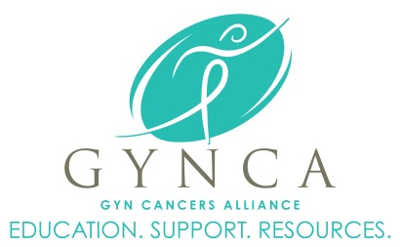

June 2016

MEMBERS ONLY

Enter Contact Information Here | 1127 Lombard Blvd. San Francisco, CA 59802 | phone 555.555.5555 | fax 555.555.5555

­

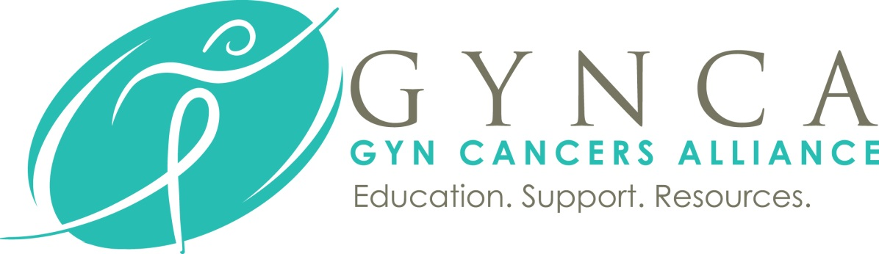

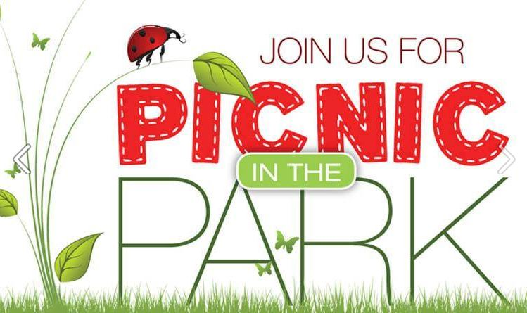

**GYNCA’s Annual Picnic in the Park! June 14th in Joplin or June 16th in Springfield**

Time for a little fun! Bring your entire family out for our Annual Summer Picnic in the Park. Each summer GYNCA invites survivors, family, friends, caregivers to the Springfield Lake Boathouse for a fun night of food, games, give-a-ways and activities. The fellowship with other survivors is always a highlight, as well as seeing how much families have grown over the past year.

Not only do we invite our Springfield area gynecologic cancer survivors for the picnic, there is a second event held in Joplin for those living a bit further out. Both events are unique and certainly fun.

Dinner is served and is absolutely FREE of charge to all in attendance. We do require an RSVP with number of adults and kids attending so we can make proper arrangements for food and drinks. Please call Jan at (417)869-2220 or email [JAN@GYNCA.ORG](mailto:JAN@GYNCA.ORG) by June 10th with a number of adults and kids in your group and which picnic you will be attending, Joplin on June 14th or Springfield on June 16th .

We look forward to seeing each of you! Please don’t hesitate to contact us if you have any questions. Happy Summer!!!

A monthly newsletter for gynecologic cancer survivors, Members Only will feature articles, stories, inspiration, events, recipes and more written for survivors by survivors. Proudly published each month by GYNCA.

GYN Cancers Alliance (GYNCA) | 3023 South Fort Ave Suite D, Springfield, MO 65807 | phone 417.869.2220

**Upcoming Events**

**June**

**14th** – JOPLIN, MO –**Summer Picnic**

Held at Cunningham Park at 6PM, join GYNCA and Freeman Cancer Center for a fun night at the park with picnic food and family games. RSVP is REQUIRED by June 10th at (417)869-2220 or email [Jan@gynca.org](mailto:Jan@gynca.org).

**16th** – SPRINGFIELD, MO – **Summer Picnic**

Held at Springfield Lake Boathouse at 6PM, join GYNCA for an evening of food, friends and fun for all ages. RSVP is REQUIRED by June 10th at (417)869-2220 or email [Jan@gynca.org](mailto:Jan@gynca.org)

**July**

21st – SPRINGFIELD, MO – **Recipes with Rizzo** - Connie Rizzo, MEd, RD, LD Medical Nutrition Therapist from the Mercy CH Chub O’Reilly Cancer Center puts her talents to work as she demonstrates how to prepare healthy and tasty recipes. Join us for a delish night of Rizzo’s best concoctions.

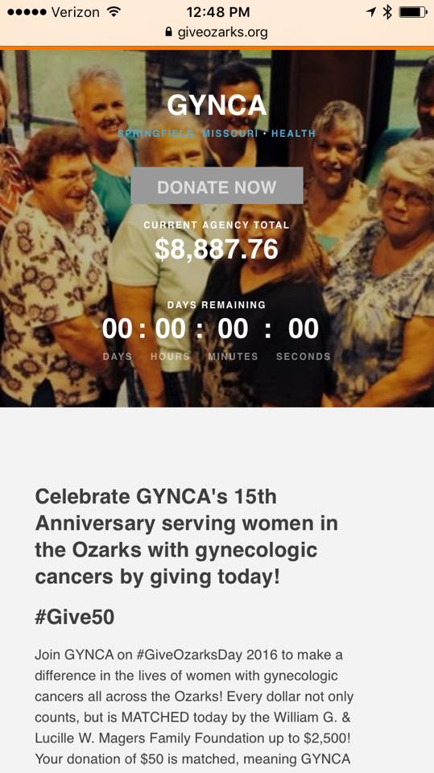

**GIVE OZARKS 2016 a BIG Success!**

On May 3, 2016 GYNCA participated in Give Ozarks, a Community Foundation of the Ozarks initiative to raise funds for organizations across the Ozarks. 220 non-profits participated in the online fundraiser that started at Midnight and ran for only 24 hours. In total the Ozarks raised over $1.2 Million for the 220 participating groups!

We cannot thank our supporters enough for helping raise $8,887.76 for the GYNCA Fuel Card Program! We also exceeded the Endowment Match by hitting $10,036.22!! Wow...you all are amazing.

www.GYNCA.org | info@gynca.org | 417.869.2220