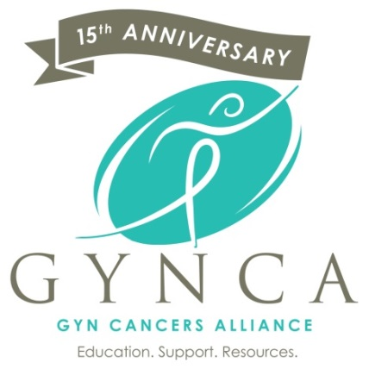 

OCTOBER 2016

MEMBERS ONLY

Enter Contact Information Here | 1127 Lombard Blvd. San Francisco, CA 59802 | phone 555.555.5555 | fax 555.555.5555

­

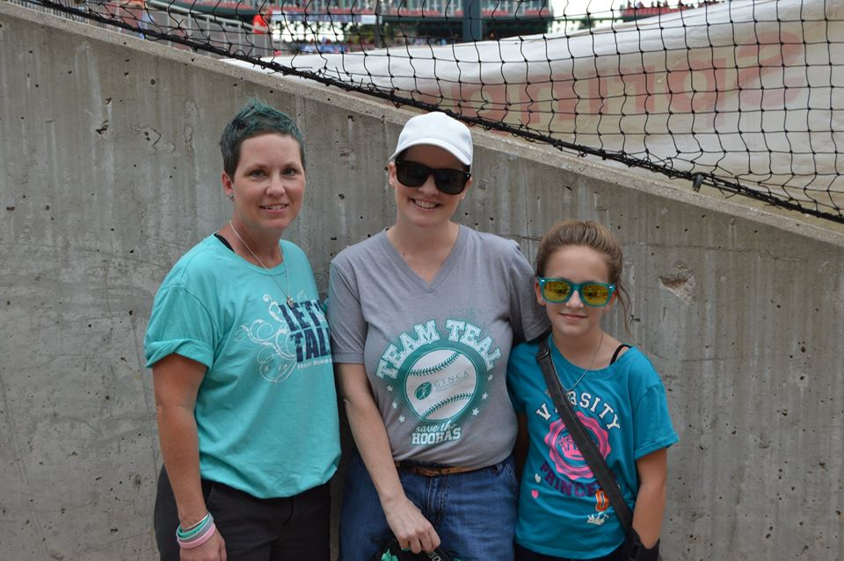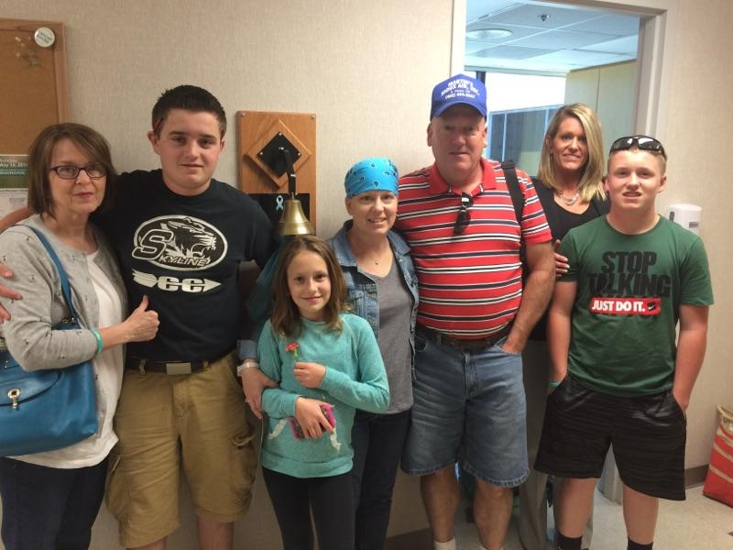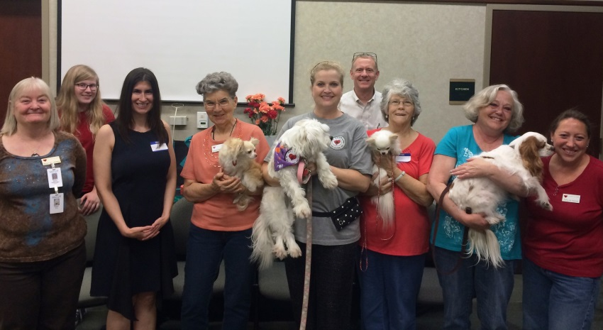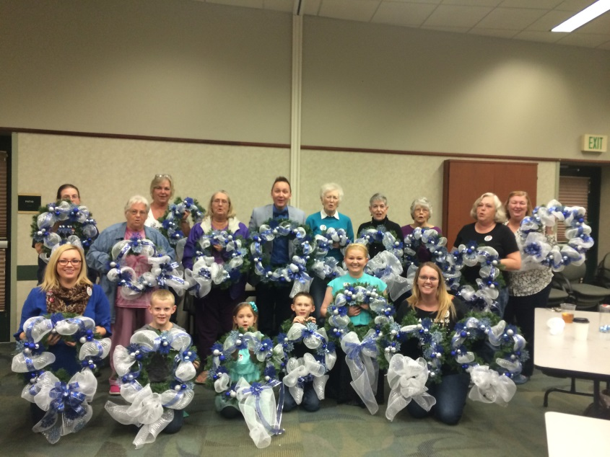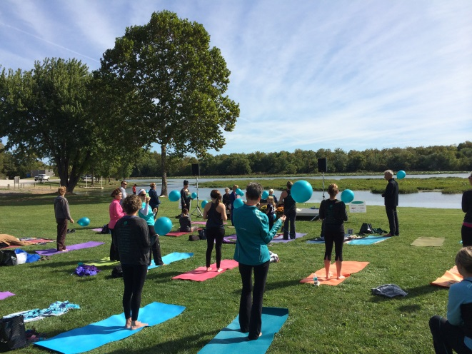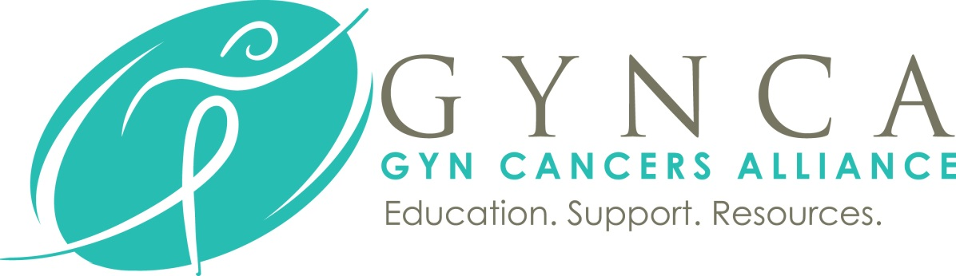

The storm has come and gone, and in the midst of it, this way-too-busy girl learned how to be still.

From that stillness, a better version of the old me has emerged, more aware of God's grace in everything.

It seems that even the birds have a sweeter song to sing. Perhaps I just wasn't listening before.

The old me was a sympathetic ear, moving on with my life as usual after lending you my shoulder.

Moving on isn't as easy anymore, because this journey through cancer has changed me.

I feel your pain and struggle now, I cry with you, your burdens become my prayers.

I know now that there is always someone, somewhere, going through a more difficult time than I am.

That I cannot judge by what I see, I have no idea what you are truly feeling inside, even if we are on similar paths.

Most mornings now, I wake up with a prayer on my lips and a thankfulness for the blessing of another sunrise.

I am living proof- God's mercies are new every day.

Written by; Nicole Fillipi, Survivor & Woman of Courage!

A monthly newsletter for gynecologic cancer survivors, Members Only will feature articles, stories, inspiration, events, recipes and more written for survivors by survivors. Proudly published each month by GYNCA.

GYN Cancers Alliance (GYNCA) | 3023 South Fort Ave Suite D, Springfield, MO 65807 | phone 417.869.2220

**Upcoming Events**

**October**

**1st** – SPRINGFIED, MO – **Cathy’s Cause Rise & Shine for a Cure!** Held at Lake Springfield Boathouse & Marina, 5324 S Kissick Avenue. 108 Salutations to the Sun! $30, incls. light brunch! Doors open at 8:30 AM – Yoga at 9:00AM. *Reserve your spot by calling Ashley at 869-2220 or email* [*ashley@gynca.org*](mailto:ashley@gynca.org)*!*

**20th** *–* SPRINGFIELD, MO – **New Hope Event, Pet Therapy of the Ozarks!** Held at The Library Center on South Campbell from 6-8PM. Join us for refreshments followed by special guests from Pet Therapy of the Ozarks. The furry friends are such a joy, join us for a fun evening!

**25th** *–* SPRINGFIELD, MO –GYNCA Night at Talbots! Share the fun & make a difference. Talbots & GYNCA invite you to shop for modern classic fall styles and enjoy light refreshments. 10% of pre-tax sales will be donated to GYNCA. 6-8PM. Battlefield Square Shoppes 3120 S. Glenstone Ave Springfield, MO. RSVP to Ashley at (417)869-2220 or [Ashley@gynca.org](mailto:Ashley@gynca.org).

**November**

**17th** – SPRINGFIELD, MO – New Hope Event, Holiday Wreath Making! Join GYNCA for a special craft night as we create stunning holiday wreaths. RSVP’s are required so we may plan for supplies. Come get in the holiday spirit with us at the Springfield Library Center on South Campbell Avenue from 6-8PM. RSVP to [Amber@gynca.org](mailto:Amber@gynca.org) or (417)869-2220.

www.GYNCA.org | info@gynca.org | 417.869.2220